Cameron Mathews

August 24, 2021

IT FDN 110 A Su 21

Assignment07

<https://github.com/cmathews10/IntroToProg-Python-Mod07>

<https://cmathews10.github.io/IntroToProg-Python-Mod07/>

# Modifying an Existing To-Do List Script and Adding Functions

### Introduction

The following document outlines the steps taken to modify and update a Python script to demonstrate Pickling and Structured Error Handling.

### Process

1. Write the script in PyCharm.
   1. I modified Assignment06 in effort to understand the impacts of Pickling and how it differs from other processes.
   2. I could not identify any user errors that would not be addressed by the current code.
2. Run the script in PyCharm (see pdf attachments).
3. Run the script in the Command Prompt window (Figure 1).

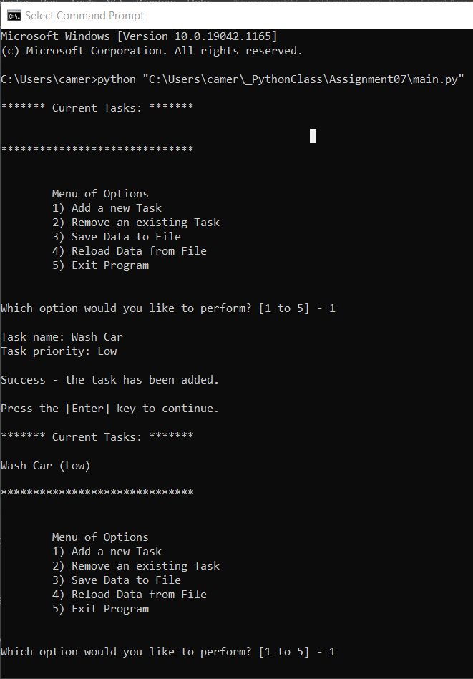

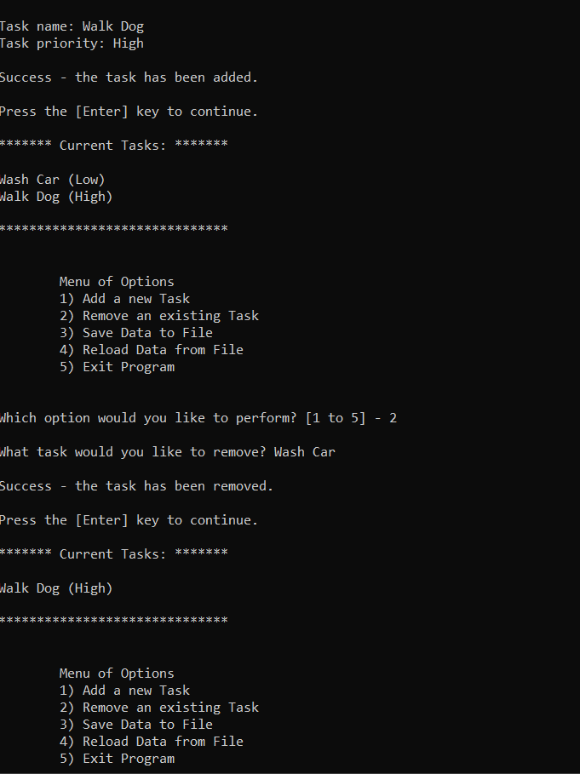

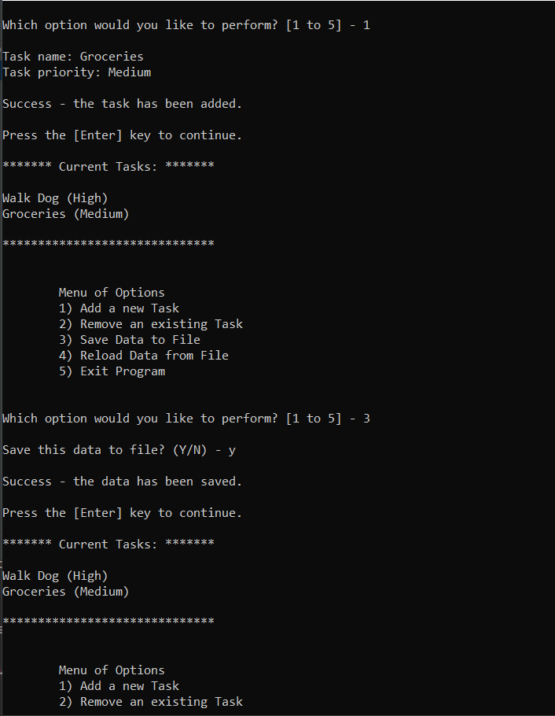

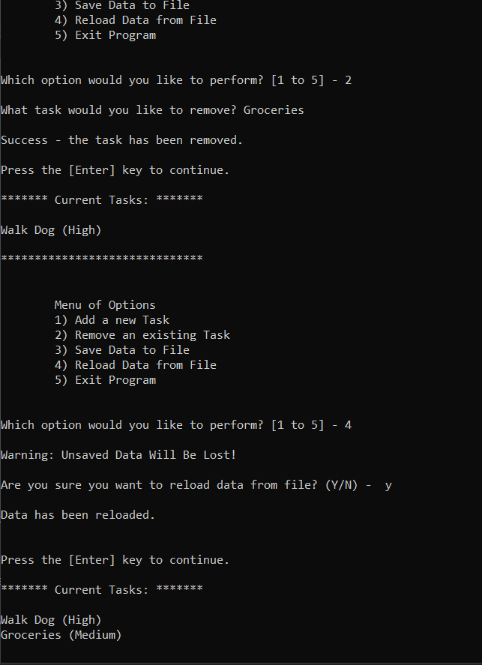

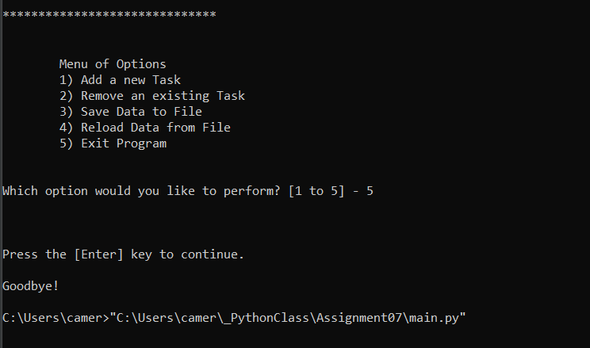

***Figure 1: Example of the script successfully running in the Command Prompt window.***

1. Confirm user input is being saved to the defined file location (Figure 2).



***Figure 2: Image of the text file that updates based on user input.***

### Summary

This document outlined the steps taken to modify and update a Python script to demonstrate Pickling and Structured Error Handling.